Ways to flash the MCU:

**SWD (Use ST-link V2) （Recommend, design for STM32）**

Component: <https://www.adafruit.com/product/2548?gclid=EAIaIQobChMI0-69o7T51gIVDzNpCh2flQ4BEAQYAiABEgIE7_D_BwE>

Connection: NRST to reset pin on STM32

SWDIO to SWDIO on STM32 (pin name: PA13)

SWCLK to SWCLK on STM32 (pin name: PA14)

GND to GND

3.3 is output (need to care the max current)

and download the drive and specific software on computer to load the code.

**Serial interface (Use CH340G)**

Component: <http://www.dx.com/p/stc-stm32-ch340g-upgraded-usb-to-ttl-downloader-green-389333#.WecN3hNSxHU> (do not include BOOT0 pin)

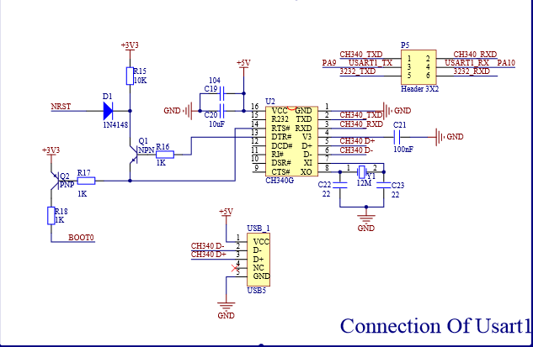

and download the drive and specific software on computer to load the code.

But both ways we need to find out a way to control BOOT0 pin on MCU to make sure the mode is right.

